**Design Data Warehouses For Given Below Products:**

**Note:** While designing any Data Warehouse make sure to cover given below points.

a. Design Fact & Dimension tables



b. Create meaningful Primary & Foreign keys



c. Try to follow Star/SnowFlake Schema Design

d. Try to write few SQL queries to generate insightful business metrics (This is the critical point because you need to understand the Data & Business both)

1. **Design a Data Warehouse for IPL Cricket Tournament**

(Asked in Flipkart Interview for Senior Data Engineer role)

VenueID

Venue_Name

Capacity

Address

Team_ID

Team_Name

Player_ID

Owner

Twitter_Followers

Fb_Followers

Insta_Followers

SocialMedia_Engagement

Social_Media_Support

MatchID

Team1

Team2

Venue

Match_Date

Digital_Viewership

TV_Viewership

Ticket_Sales

**Fact Table**

**TeamID**

**MatchID**

**VenueID**

**PlayerID**

PlayerID

TeamID

PlayerName

Nationality

BasePrice

1. **Design a Data Warehouse for Food delivery app like Swiggy, Zomato (Asked in Grab for Data Engineer role)**

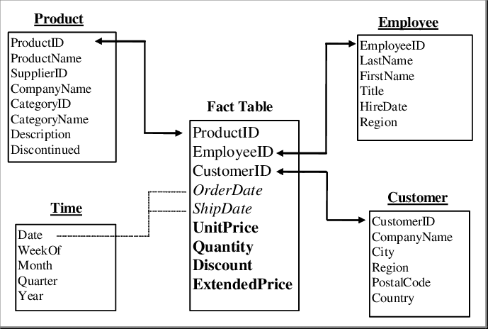

1. **Design a Data Warehouse for cab ride service like Uber, Lyft**

**(Asked in Google for Data Engineer role)**

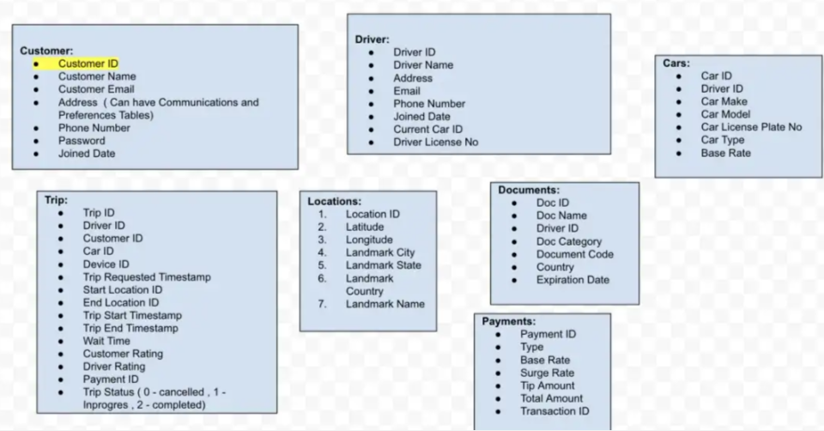

1. **Design a Data Warehouse for Restaurent table booking app like Dineout**

**(Asked in**

**McKinsey for Consultant Data Engineer role)**

